# CS 255 System Design Document Template

## UML Diagrams

### UML Use Case Diagram

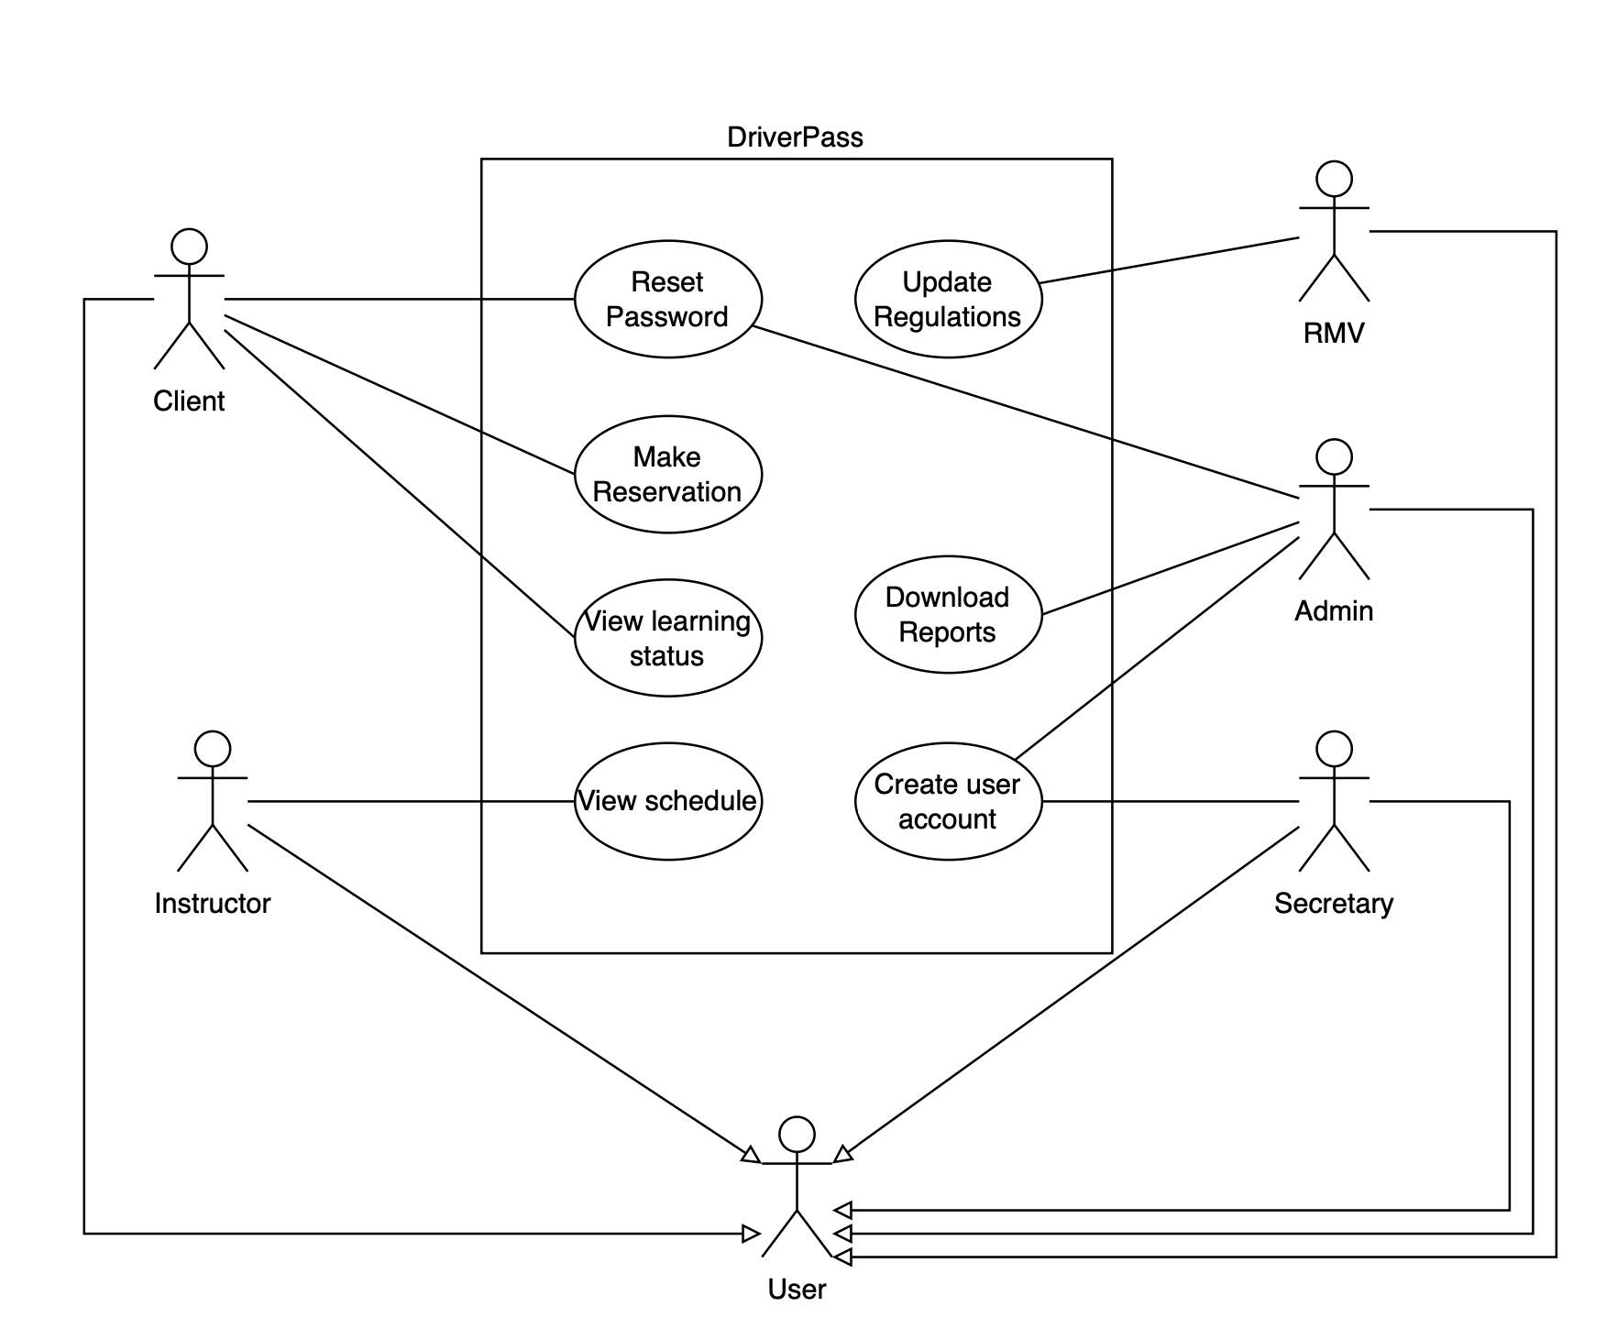

### UML Activity Diagrams

### UML Sequence Diagram

### UML Class Diagram

## Technical Requirements

* This system needs to be web based according to the requirements. Given this requirement, the system will require web servers. Linux based web servers are the standard for building web-based systems because of their low hardware footprint and low cost. Because the system needs to be low maintenance, the design will leverage cloud-based Linux server instances. This reduces the overhead of having to manage hardware and datacenter infrastructure.
* To keep maintenance and cost as low as possible, PaaS based databases will be leveraged to provide the data storage needs.
* A web framework like Angular should be used to ensure we can meet the tight deadline. It will help us to conform to standards and speed up development times.
* Load balancers should be used to help scale the application according to user load.